**The Making of Agastya Academy's Annual Class Plays**

At Agastya Academy, the festive season took on a magical turn through our captivating annual class plays for UKG, Grade 1, 2, and 3. Every performance of the children showcased the true essence of creativity in its own unique and magical way.

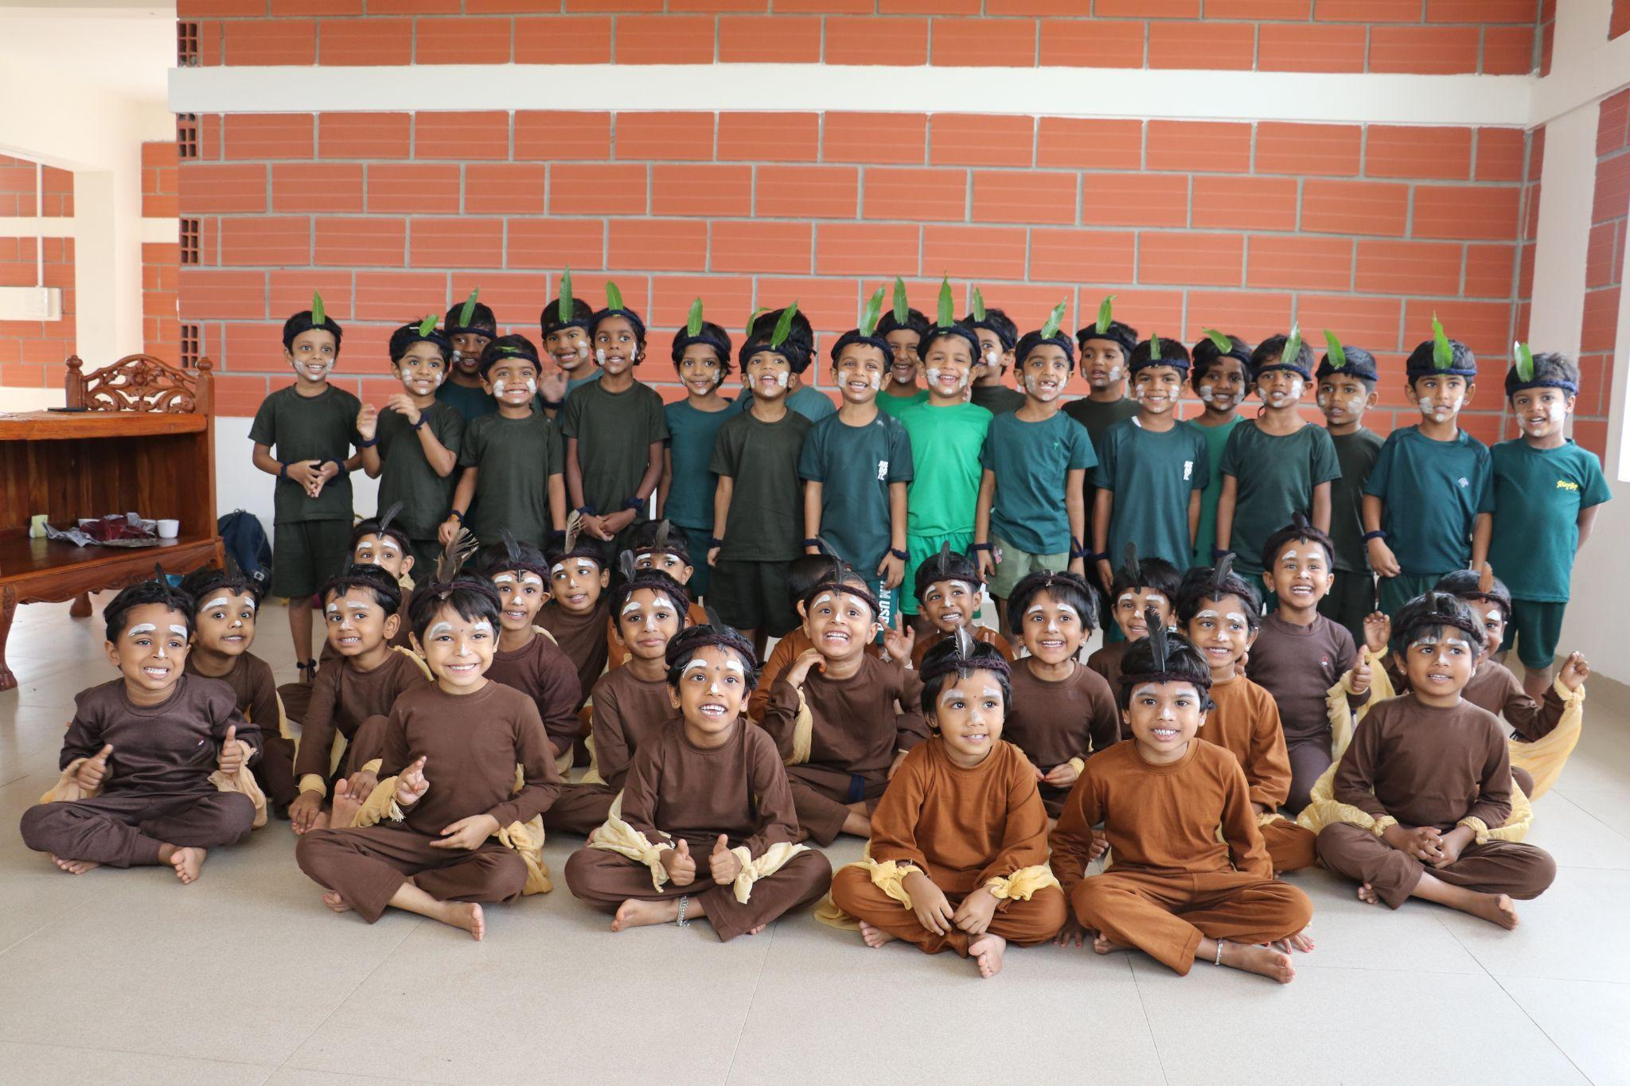

They are not just performances; they are pedagogical dramas designed to serve a profound educational purpose. In the Waldorf tradition, these play a crucial role in the students' development, enhancing their skills, fostering a sense of interdependence, and igniting creativity through the medium of drama.

[Click here more……………](https://www.agastyaacademy.edu.in/post/the-making-of-agastya-academy-s-annual-class-plays)